**Activity 1 -Filtering Data Part02**

**Exercise 1**

SQL Code:

SELECT *

FROM employees

WHERE

first_name like 'P%'

AND

salary < 8000;

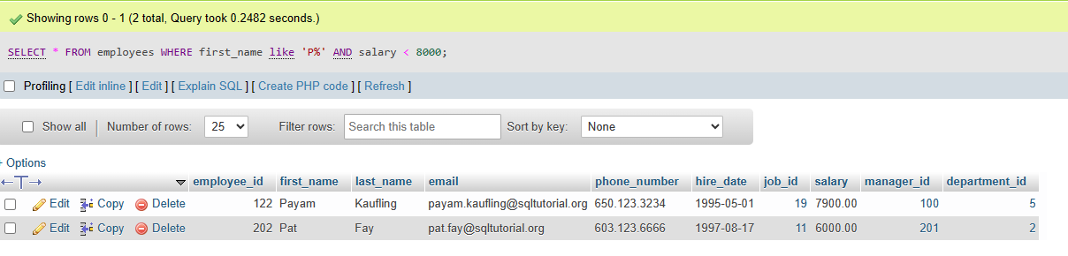

Exercise 2

SQL Code:

SELECT *

FROM

employees

WHERE

Year(hire_date) >=1997

AND

YEAR(hire_date) <= 1998

AND

department_id = 5;

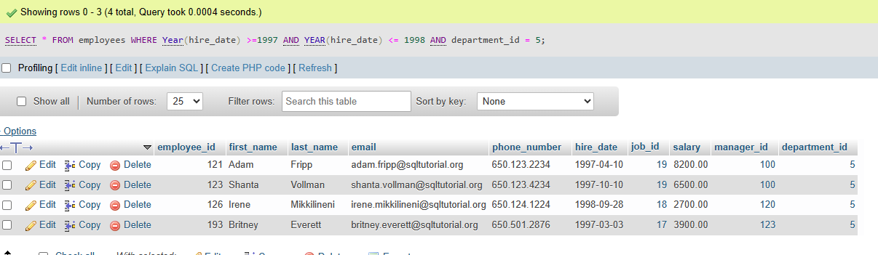

Total number of records = 4

**Exercise 3**

SQL Code:

SELECT

first_name,

last_name,

salary,

email,

YEAR(hire_date) AS 'Year of Hire'

FROM

employees

WHERE

YEAR(hire_date) between 1998 AND 2000

ORDER BY

last_name;

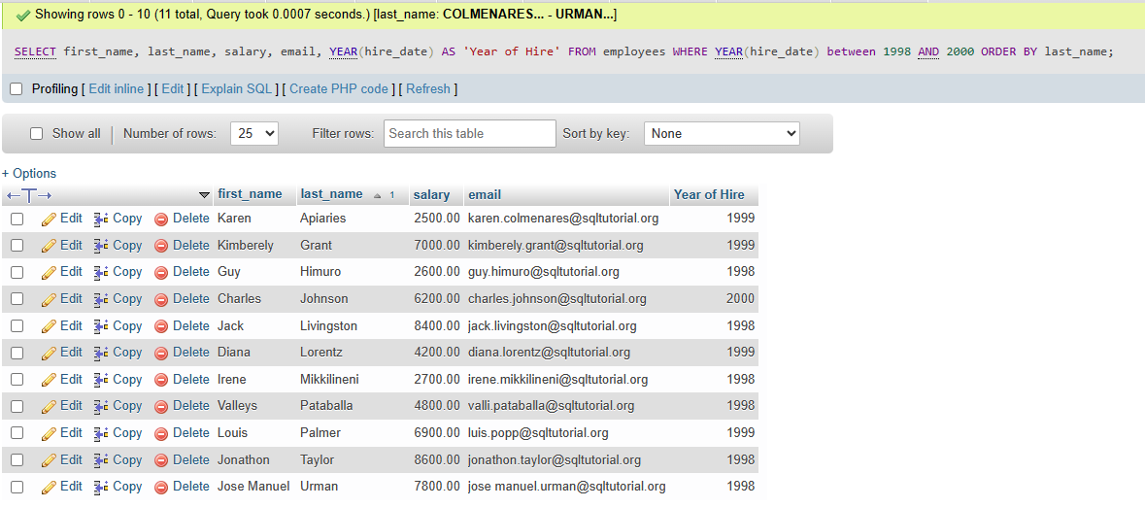

Total number of records = 11

Exercise 4

SQL Code:

SELECT *

FROM employees

WHERE

salary >= 5000 And salary <= 10000;

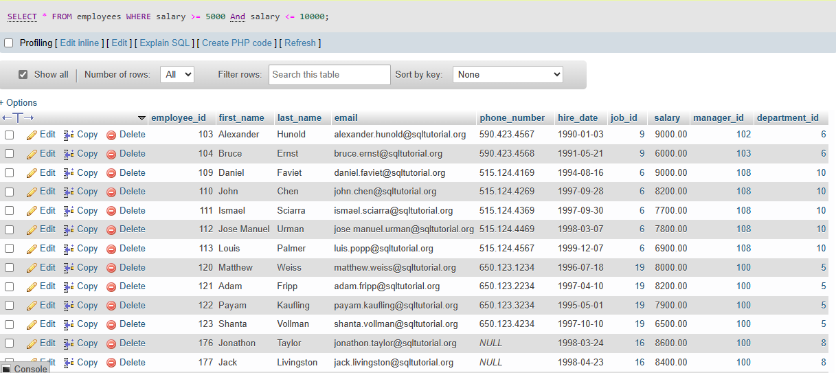

Total number of records: 19

Exercise 5

SQL Code:

SELECT *

FROM employees

WHERE

salary between 4000 And 12000

ORDER BY

first_name;

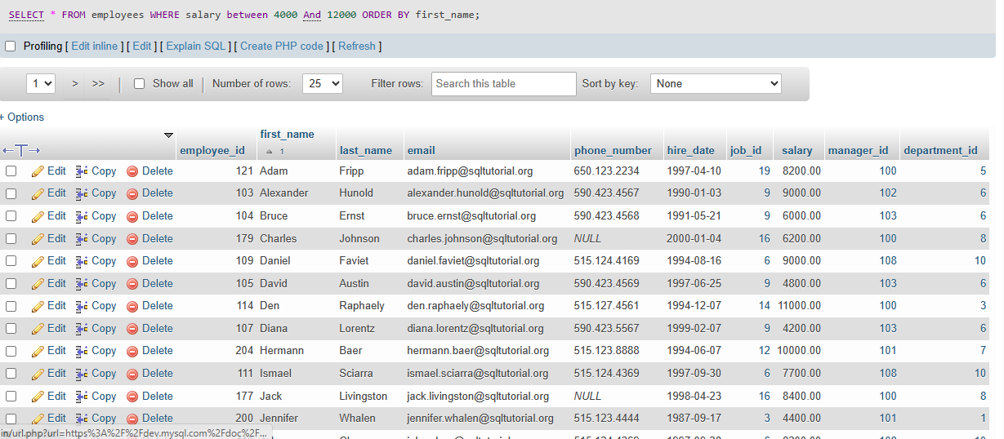

Total number of records: 27

Exercise 6

SQL Code:

SELECT

*

FROM

employees

WHERE

department_id NOT IN (1, 4, 8, 10)

ORDER BY salary DESC;

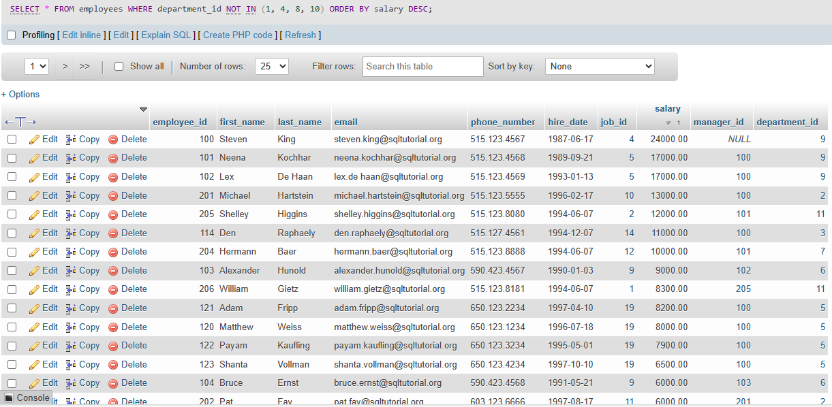

Total number of records: 26

Exercise 7:

SQL Code:

SELECT

*

FROM

employees

WHERE

first_name LIKE '%s'

ORDER BY first_name ASC;

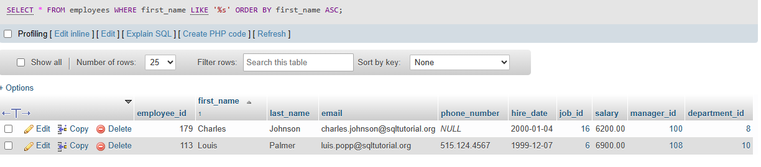

Total number of records: 2

Exercise 8

SQL Code:

SELECT

*

FROM

employees

WHERE

last_name LIKE '___g%';

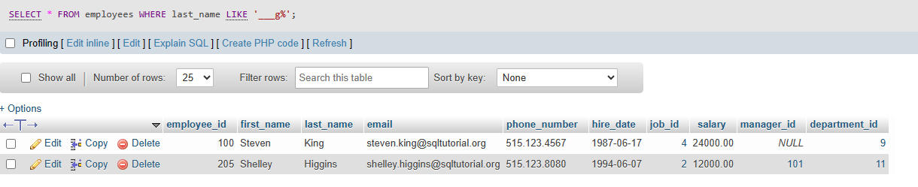

Total number of records: 2